Project Heart: Game Design Document

# Classification

* Genre: narratively explorable escape room
* Platform: PC
* Target Group: Mature audience

# Story

Diego’s heart is broken into pieces after breaking up with their abusive partner, Taylor. The three pieces of his heart are now governed by three negative emotions. Anxiety is now tasked to deal with this situation.

# Gameplay

To progress in the game, you need to escape from several rooms within the heart. You may choose to solve the puzzles in each room and comfort each of the emotions with the help of narrative clues in the environment. However, you may also choose to destroy the puzzles and murder these negative emotions.

# Unique Selling Point

The unique selling point of this game is that the player can consume the narrative in any way they choose. This way choice is not a game mechanic but rather a product of the player being free in this explorable environment.

# Characters

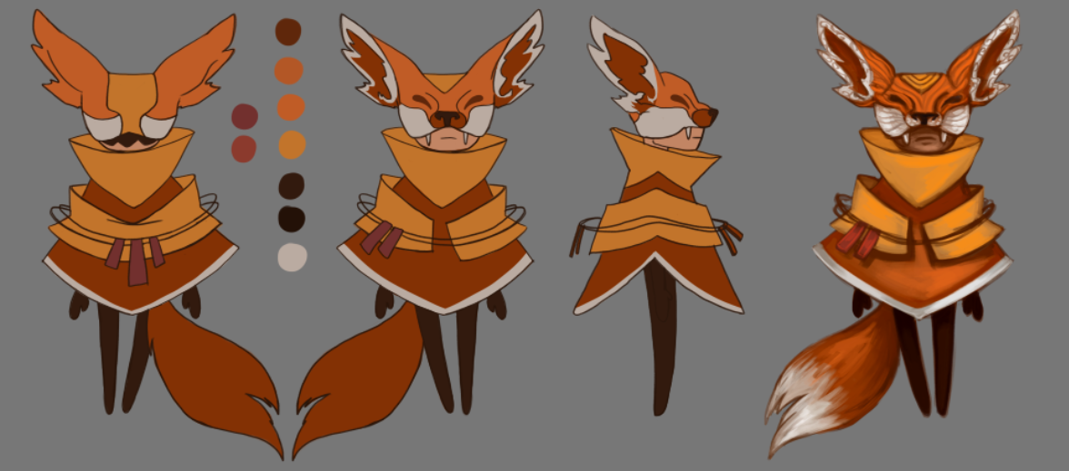

This is Anxiety, our player-controlled character. They are a nervous wreck that tries to keep its cool but fails more often than not.

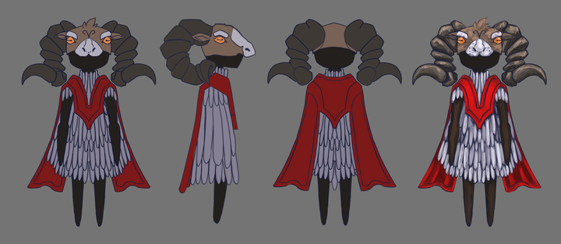

This is Anger, keeper of the library.

Fear, keeper of the Greenhouse; and Sadness, keeper of the void; will be developed later.

# Game Mechanics

**Narrative in items:** Most items in the game will have a narrative reason for being there. The goal is to reward the player with information about the outside story for exploring the world, while also giving them the option to skip this if they’re not interested in this aspect of the game.

**Interaction item-environment:** Often to advance you to have to use an item on the environment. Like for example say you had the key and wanted to use it on a door. The way this works in game is first you have to the item selected from inventory (the selected item is shown constantly on the top left of the screen) and then click to interact on the desired environment object. Depending on our wishes the item may disappear from the inventory once used.

You may pick up items even though you have an item selected from your inventory.

If you try to interact with an environment that doesn’t react to your item (say for example you click on the door while holding a water bottle) the same message shows as it would if you had no item selected (here for example “This door is locked, I wonder where the key is”)

**Interaction item-item:** In your inventory you have the option to merge items together, creating a new one. An example for this would be to merge powdered milk with a glass of water to create a glass of milk.

**Knowledge Test:** The last challenge when finishing a level is a dialogue with the emotion of said level. Narratively the emotion is trying to get you to prove that you care about them by asking you questions about the outer story. As a mechanic what this does is test the player’s knowledge about the outside story, check if they have read the flavor text in the environment and items, and lastly end any misconceptions the player might have picked up about the outer story.

# Setting/Lore

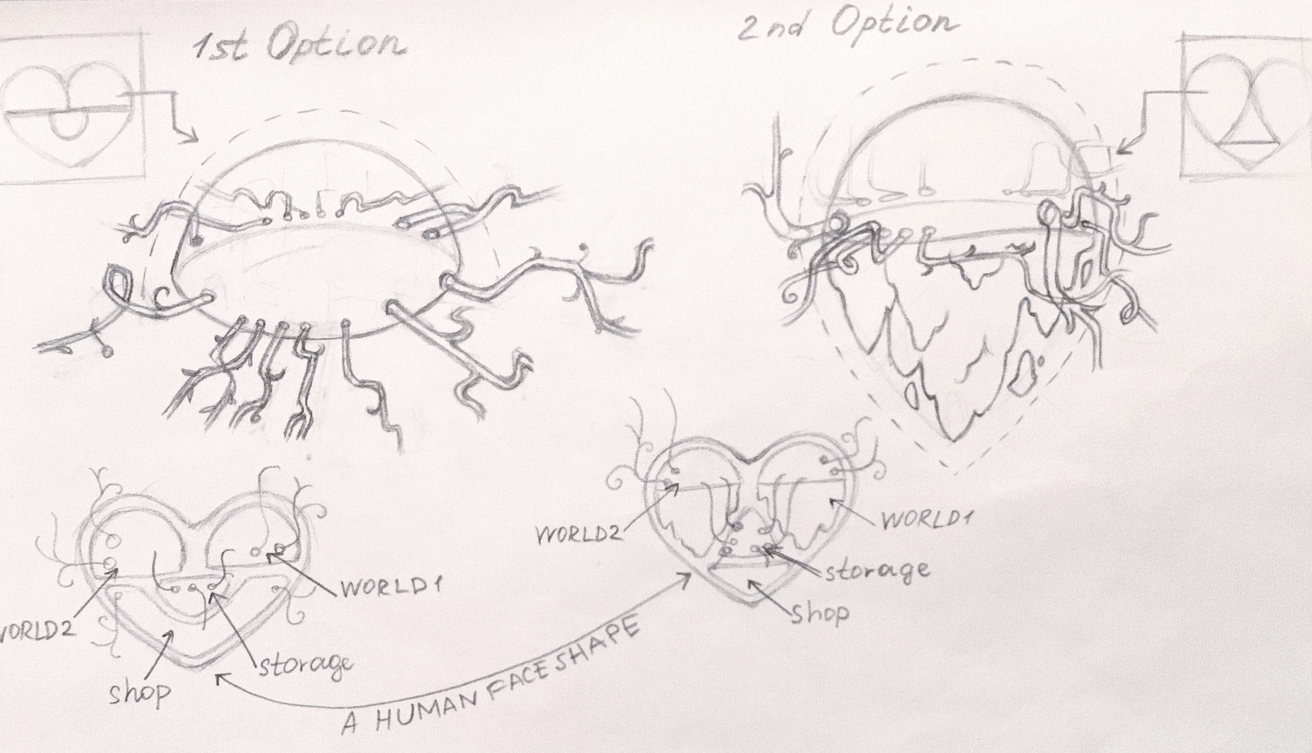

This game’s setting is the broken heart of Diego

# Level Art

## Library Level, Childhood Room

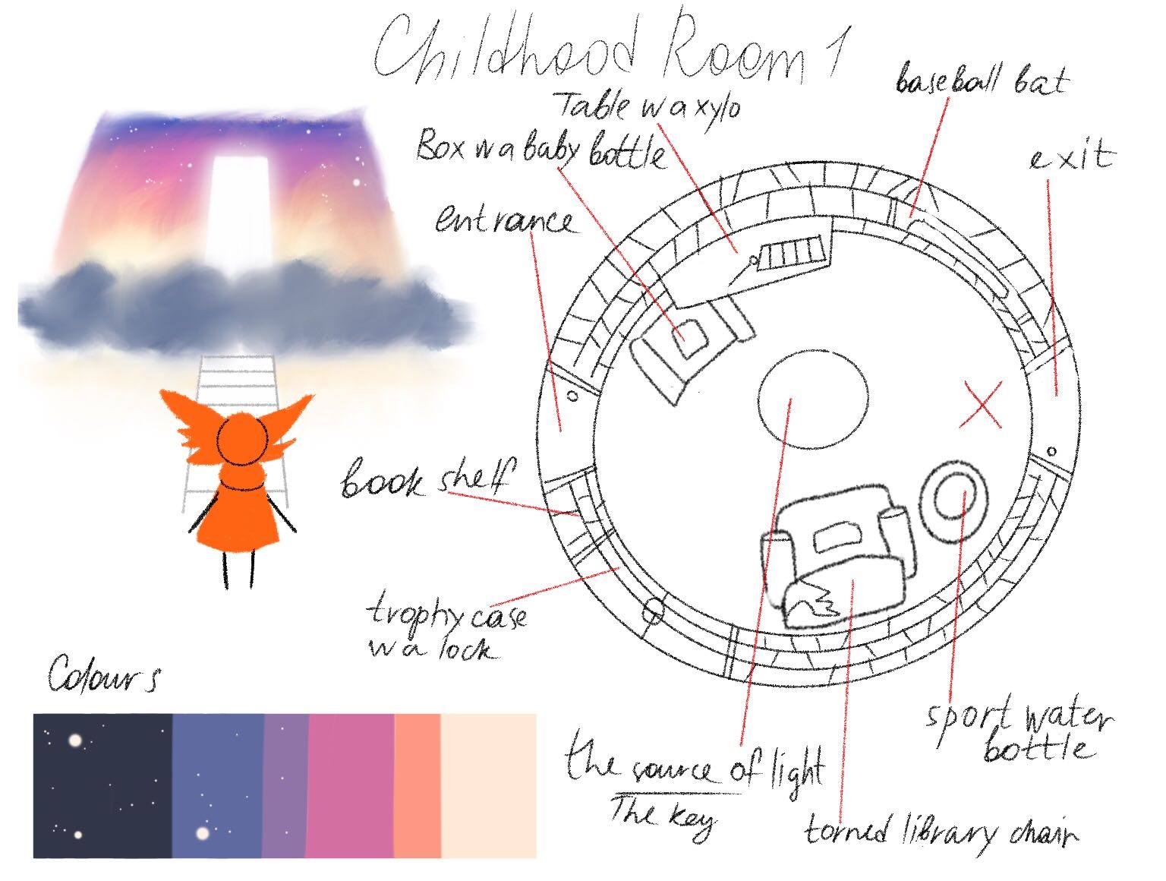

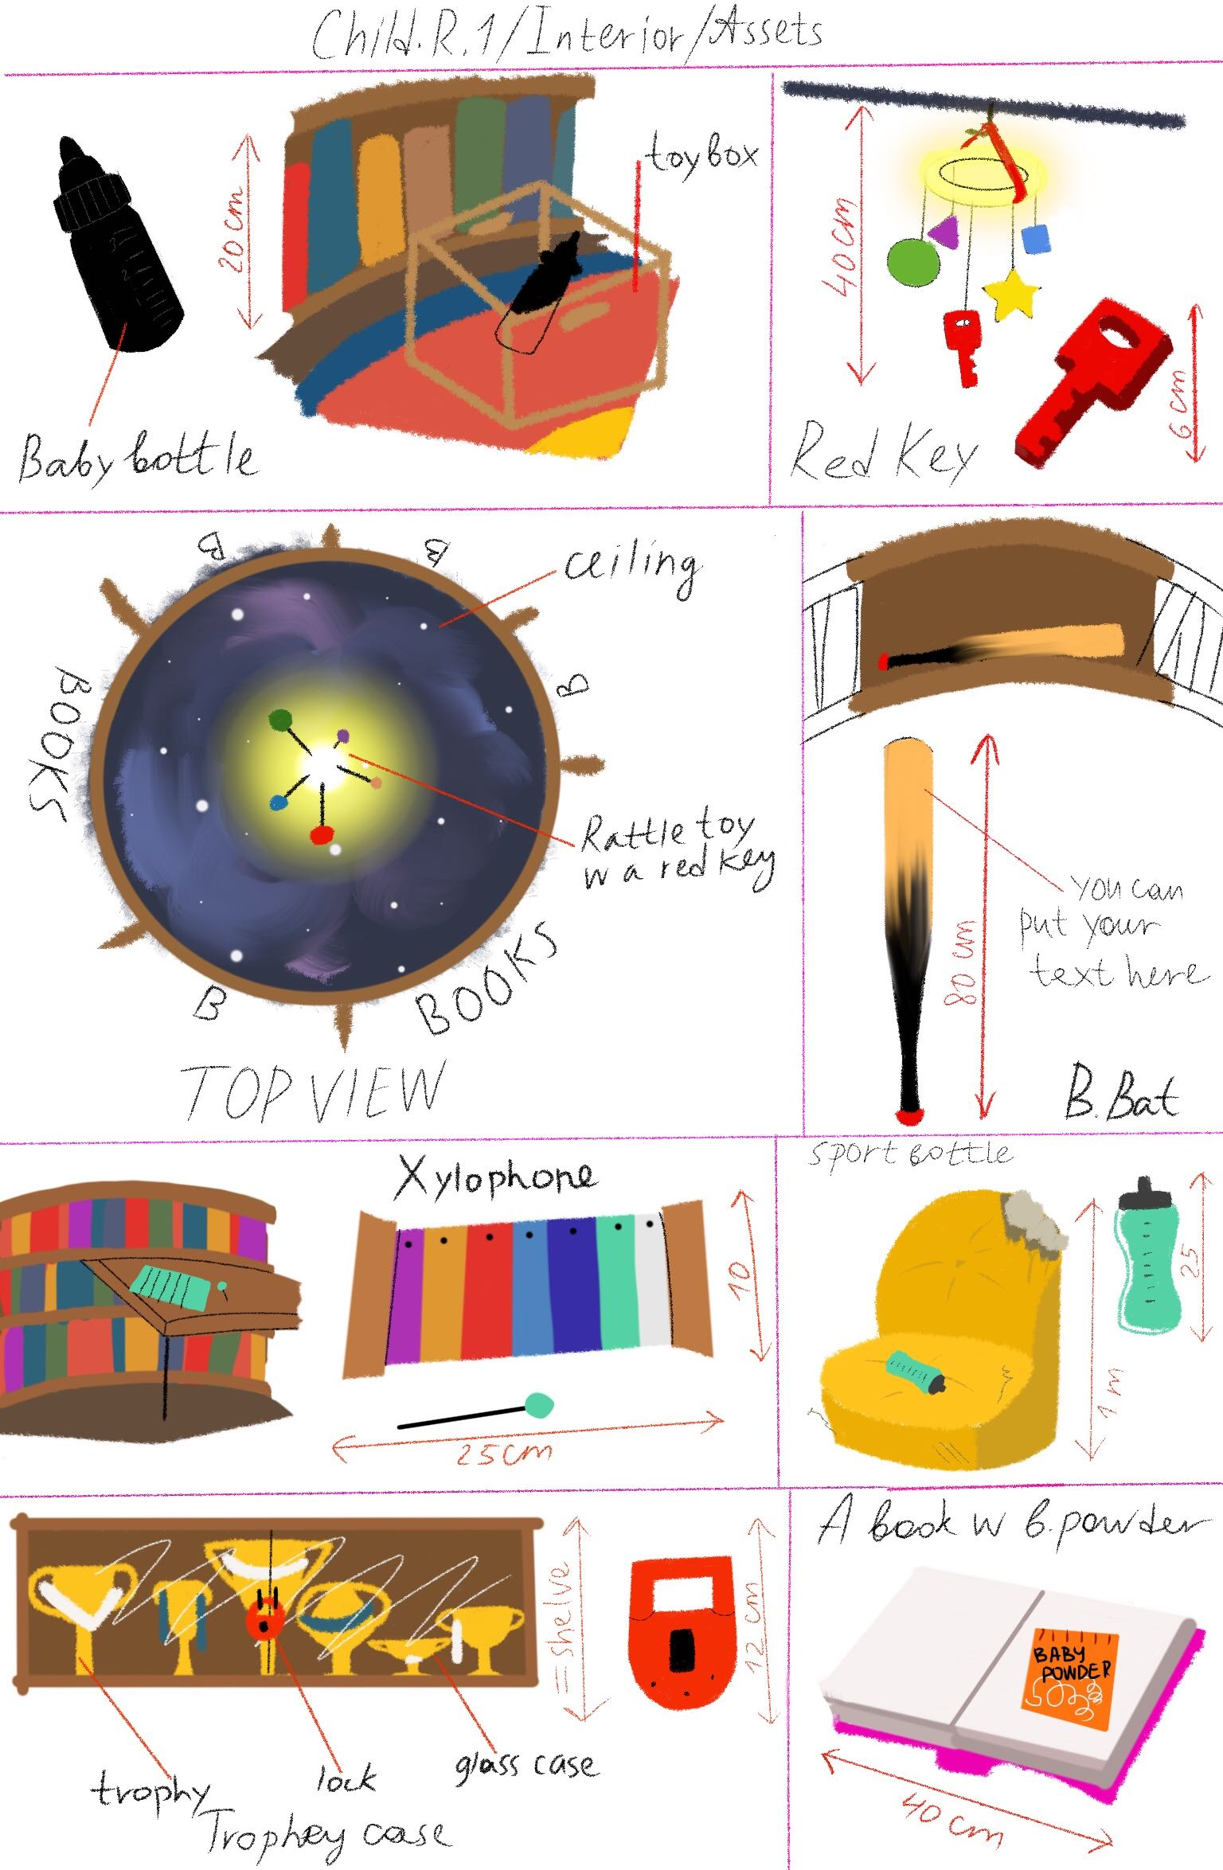

## Library Level, Letters Room

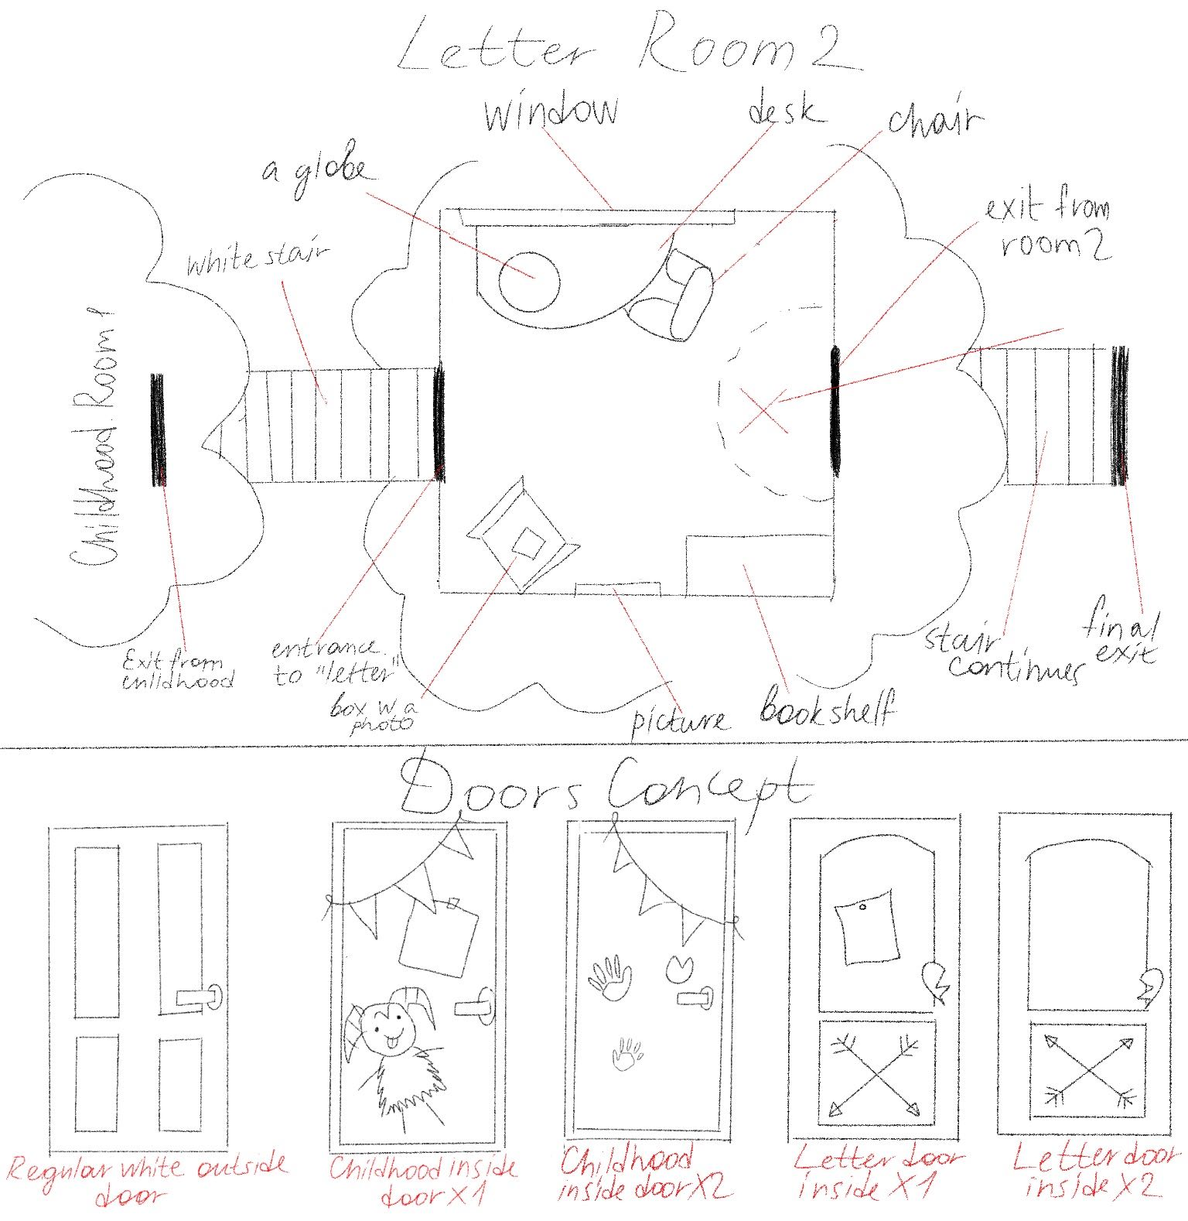

## Greenhouse Level Concept Art

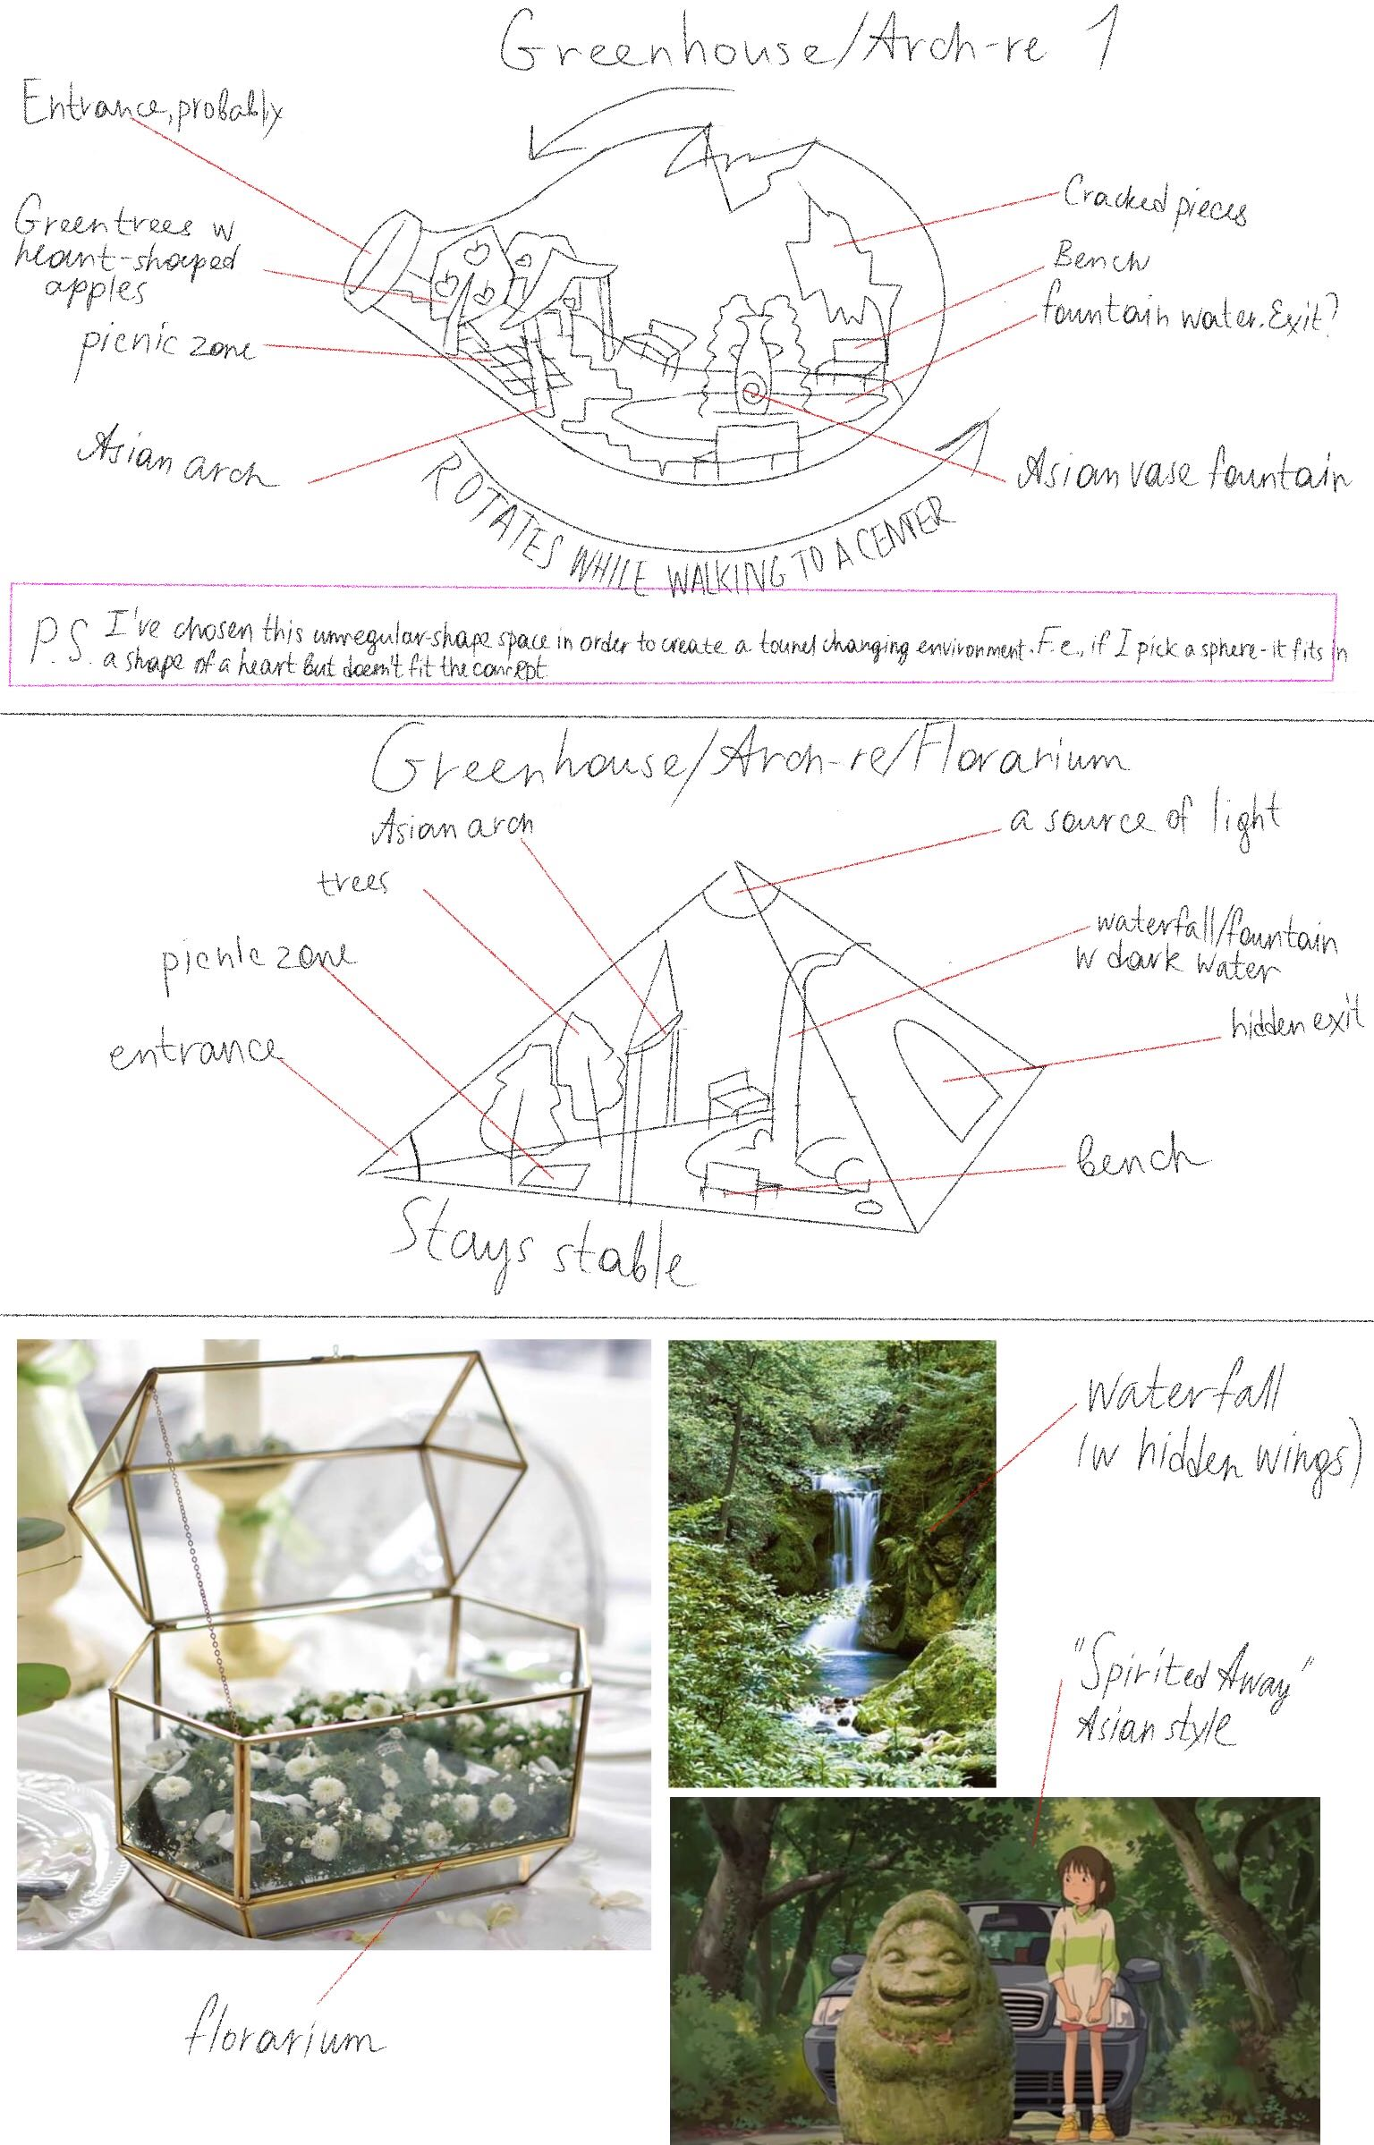

# Multiple Endings

This game features 3 endings that depend on the player’s actions in the game.

**Good Ending:** You solved all the puzzles without the use of weapons and comforted all the emotions. For this reason Diego is now healed and able to love romantically again.

**Bad Ending:** To get this ending you have to kill all of the emotions.

**Neutral Ending:** To get this ending you have to either break a puzzle with the use of a weapon, murder less than 3 emotions, or fail too many times on the last Knowledge Test of each level.

# Escape Rooms Cheat Sheet

(PU) means that an item can be picked up

# Library Level, Childhood Room

## Things available from the start

* Black Baby Bottle (PU)
* Rattle toy with Red Key (PU)
* Baseball bat (PU) (This is this level’s weapon)
* Xylophone with white keys

## How to solve the puzzle

After picking up the Red Key from the rattle toy, head to the Trophy Case with the big red keyhole and open it. Pick up the Sports Water Bottle inside.

The Xylophone has 8 white keys of receding size. The 8 trophies of receding size have white or red ribbons on them. Walk up to the Xylophone and touch the corresponding keys to turn them red. When done correctly you hear a clicking sound, and a book pops out of a shelf. This book contains Baby Formula (PU).

Combine the Black Baby Bottle, Sports Water Bottle and the Baby Formula. This reveals that the Black Baby Bottle had “paint gaps”; with the contrast of the white milk on the black bottle these gaps are now visible. The word “HELP” is now seeable in white on the bottle.

Type “HELP” into the door input to escape.

# Library Level, Letter Room

## Things available from the start

Taylor’s letter on top of the Desk with “PS: ILOVEYOU, TAYLOR” written in Tic-Tac code (PU)

## How to solve the puzzle

Notice Painting is crooked because of a dust mark on the wall. When you fix said Painting a Magazine will fall from behind it.

This magazine will enumerate 10 countries:

“1 – Germany; 2 – England; 3 – Canada; 4 – Sweden; 5 – Australia; 6 – India; 7 – the US; 8 – Spain; 9 – Japan; 10 – Russia”

Look at the Globe/Map and write down the colored patterns of the previously mentioned countries, from doing this you should get:

“1 – Blue; 2 – Green; 3 – Brown; 4 – Purple; 5 – Yellow; 6 – Brown; 7 – Pink; 8 – Orange, 9 – White; 10 – Red”

This is the order in which you should put the color patterned books on the bookshelf first blue, red last.

By looking at the way the books are now arranged they make a code “17/07/2019” (this is because the brown books don’t have a number on their back)

Put this code into the locked cabinet of the desk. This will open it and give you a Tic-Tac code translation sheet (PU).

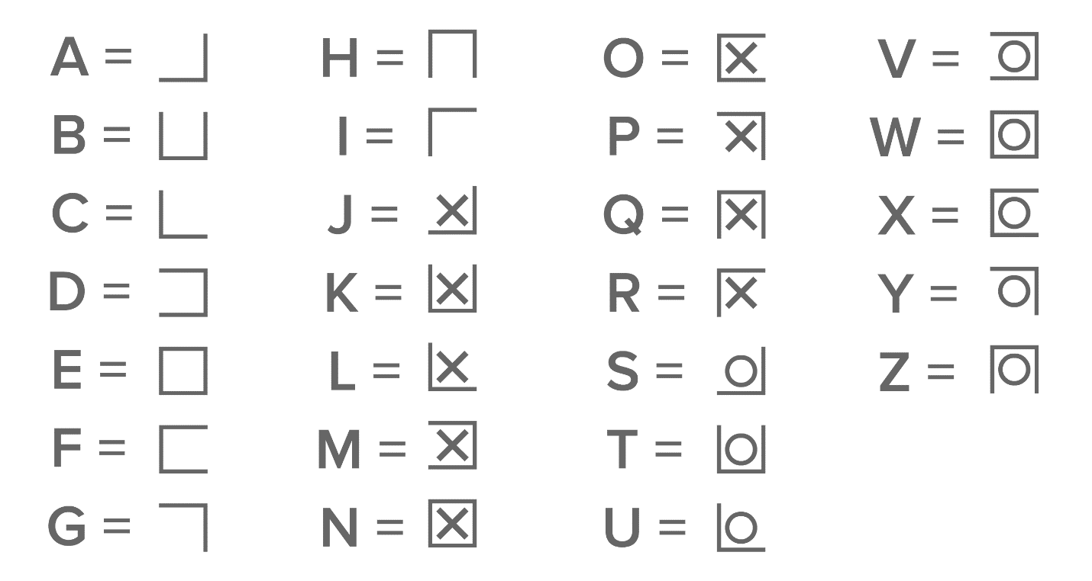

Use this code to Translate Taylor’s letter and then input the message in the box’s code field.

Opening the box gives you a Polaroid of Diego (the outer protagonist) and a kid in a nursery gown with “thank you” written on it.

With this the Room is solved! Present the photo to Anger to start the knowledge test.